Nepal College of information Technology
Balkumari lalitpur
Assessment Exam Fall Semester 2008

Program : ELX Semester: Fall
Time : 3hrs Year : 2008
Level: Bachelor Full marks: 100

Control System

1. a) Differentiate between open loop and closed loop control systems. Also point out the importance features of feedback in a system. [7]
b) A mechanical system is represented as shown in the figure below:
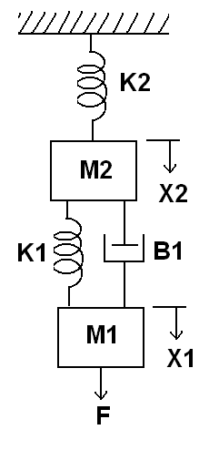
Obtain the mechanical equations and also draw the force voltage analogy and force current analogy of the given system. [8]

2. a) Obtain the overall transfer function of the system shown in the figure using signal flow graph technique [7]
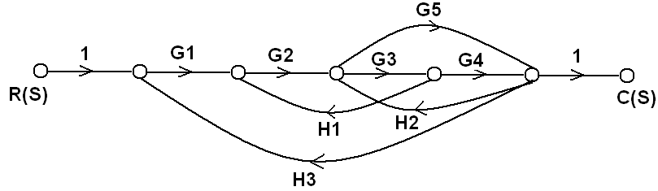

b) Determine the overall transfer function C(s)/R(s) for the system represented by the block diagram shown below. [8] 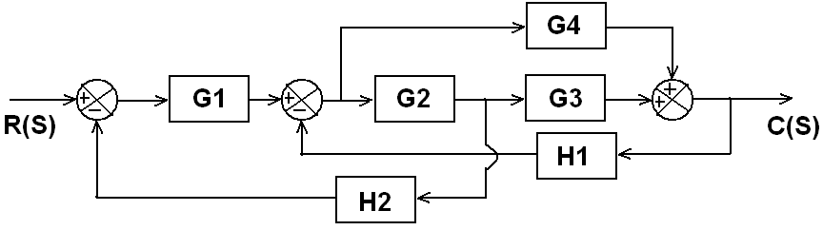

3. a) Determine the state model for the electrical circuit shown in the figure. Represent i(t) and V₀ as state variables. [7]
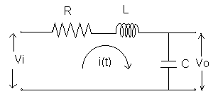

b) Obtain the state model for the transfer function given below
Y(s)/U(s) = ( s²+3s+1)/ (s³+ 8s² +25s +24)
Use direct decomposition method. [8]

4. a) The open loop transfer function of a unity feedback control system is given by
G(s)=K/{s (s+2) (s+10)}
Find the static error constant and steady state error of the system when subjected to input
r(t) = 1 + t + (t²/2) [7]
b) The open loop transfer function of a unity feedback control system is given by
G(s)= K/{s(1+sT)}
Determine the value of K& T that will give the Maximum overshoot of 5% and the settling time (2%) of 2 second for the unit step input. [8]

5. a) The open loop transfer function of a certain unity feedback system is
G(s)= 10/{s(0.5s+1)( 0.1s+1)}
Construct the Bode Plot. Also determine gain margin and phase margin and check stability. [8]
b) The open loop transfer function of a unity feedback system is given as:
G(s)= K/(s³+ 2s +4)
Using Routh’s criteria determine the range of K for which the system is unstable. [7]

6. Sketch the root locus of open loop transfer function with unity feedback as
G(s)= K/{s (s+2) (s+3)} [15]

7. Write short notes on (Any two): [5*2=10]
a) Encoders
b) Rise time (tr) for a second order system
c) Relative and absolute stability

